A) Import Data:
● Import “List of Orders.csv” into Power BI. ● Open “List of Orders” in Power Query Editor by clicking on ‘Transform’. ● Import “Order Details.csv” and “Sales target.csv” into Power Query Editor.
Open Power BI Get dataText/CSVImport the “List of orders.csv” file Power Query Editor by clicking on ‘Transform’then click new sources and import “Order Details.csv” and “Sales target.csv” into Power Query Editor.
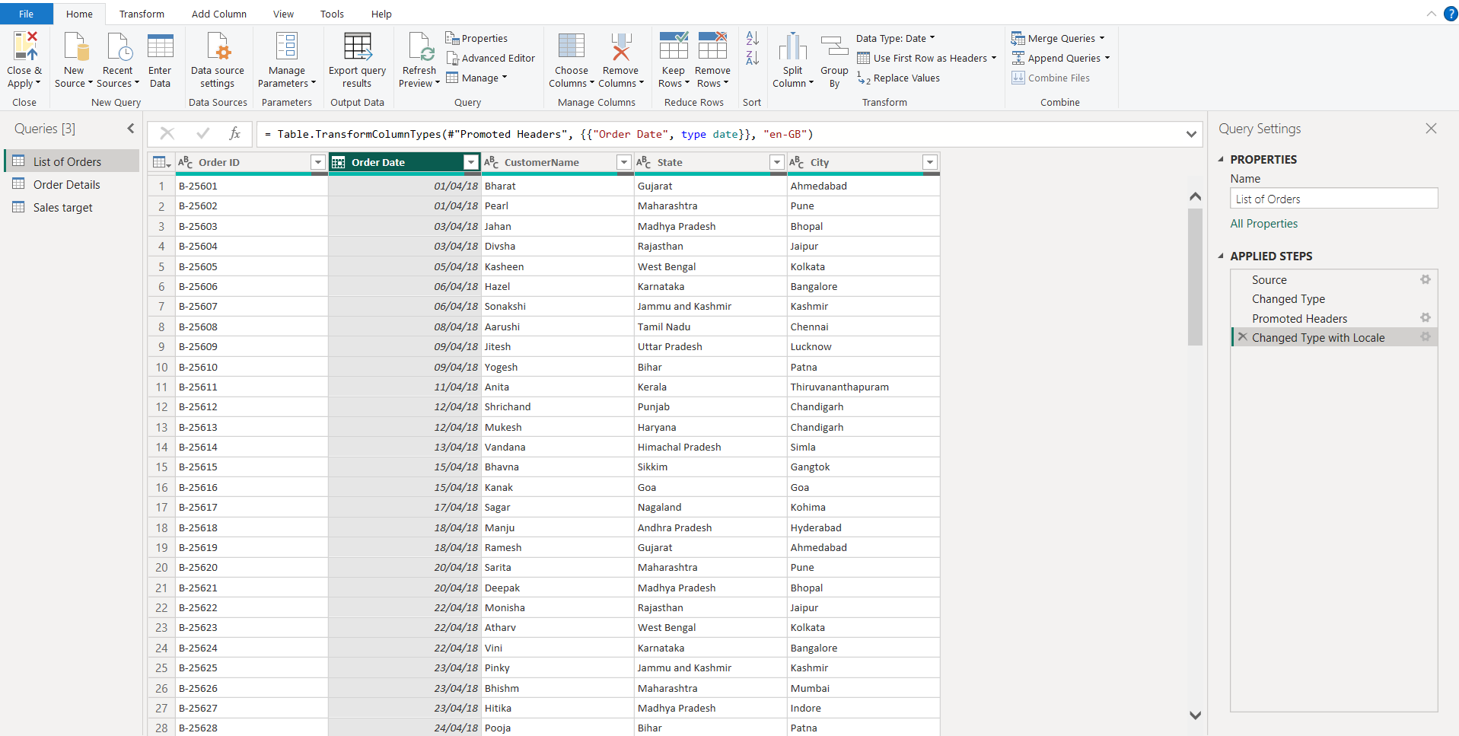
B) Data Transformation:
● Restrict the "List of Orders" table to only the first 500 rows. Select the “Keep Rows” option and type 500 in “Number of rows” option.
● Ensure the “Order Date” column in the “List of Orders” table is set to data type 'Date'. Changed the type of “Order Date” to date.
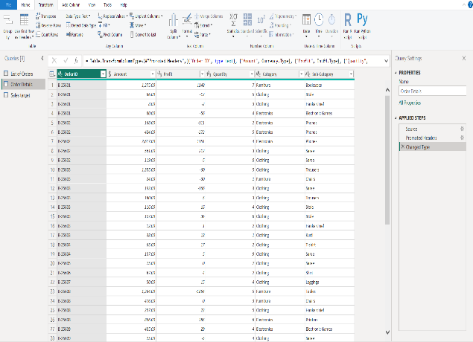
● Change the data type of “Amount” and “Target” columns to ‘Fixed Decimal Number’. By selecting the ‘Fixed Decimal Number’ the “Amount” and “Target” columns are changed.
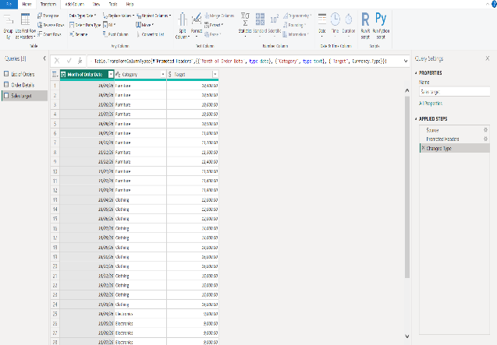

● Format the "Customer Name" column into proper case, ensuring consistent capitalization for each word. “Transform” ”Format” capitalization for each word
● Merge the "State" and "City" columns to create a new column named "Location" in the format ‘City, State’. Interchange the “state” and city column then merge the 2 columns using “Merge Columns” in “Transform” option. Then change the column name to location.
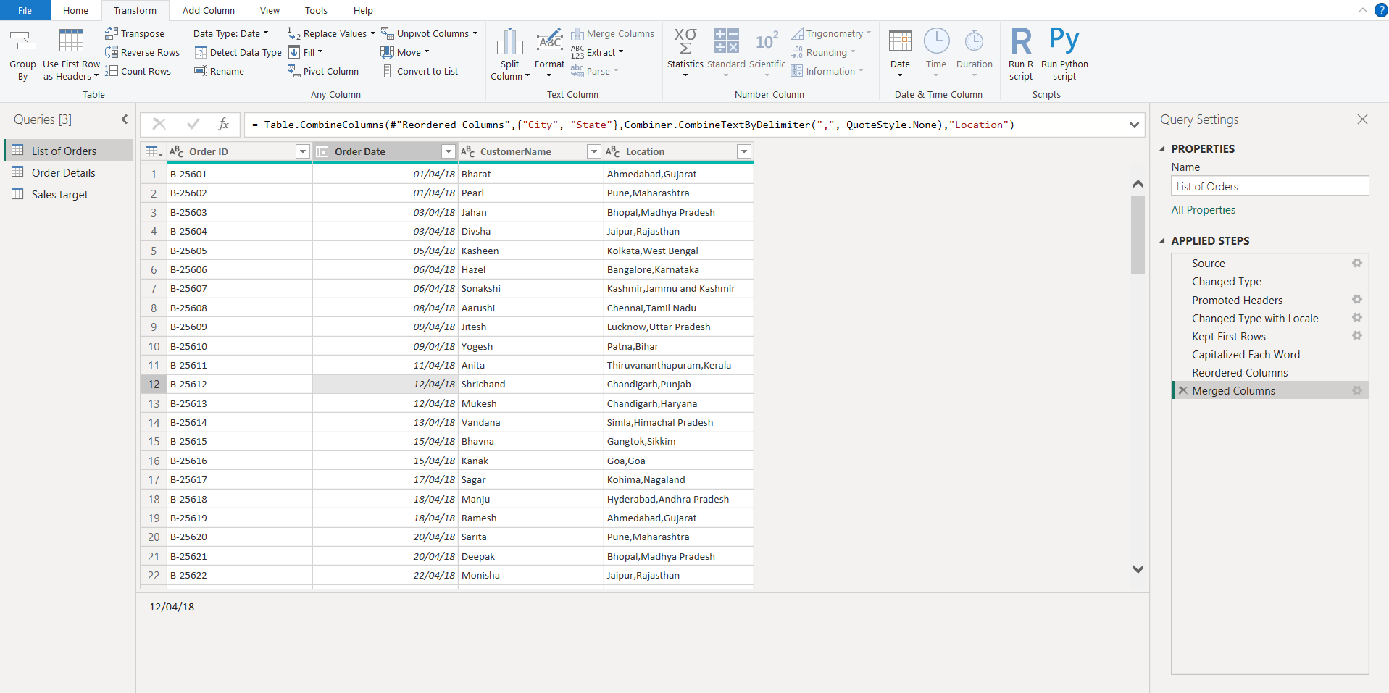

● Create a new custom column named "Profit Margin" as the percentage of "Profit" divided by "Amount".
Add columnCustom Column then type “profit margin” in column name then give formula “profit/amount”
● Add a new conditional column named "Profit Status" based on the values in the "Profit" column. The conditions are as follows: if the profit is less than 0, the label should be "Loss"; if the profit equals 0, the label should be "Break-Even"; and if the profit is greater than 0, the label should be "Profit".
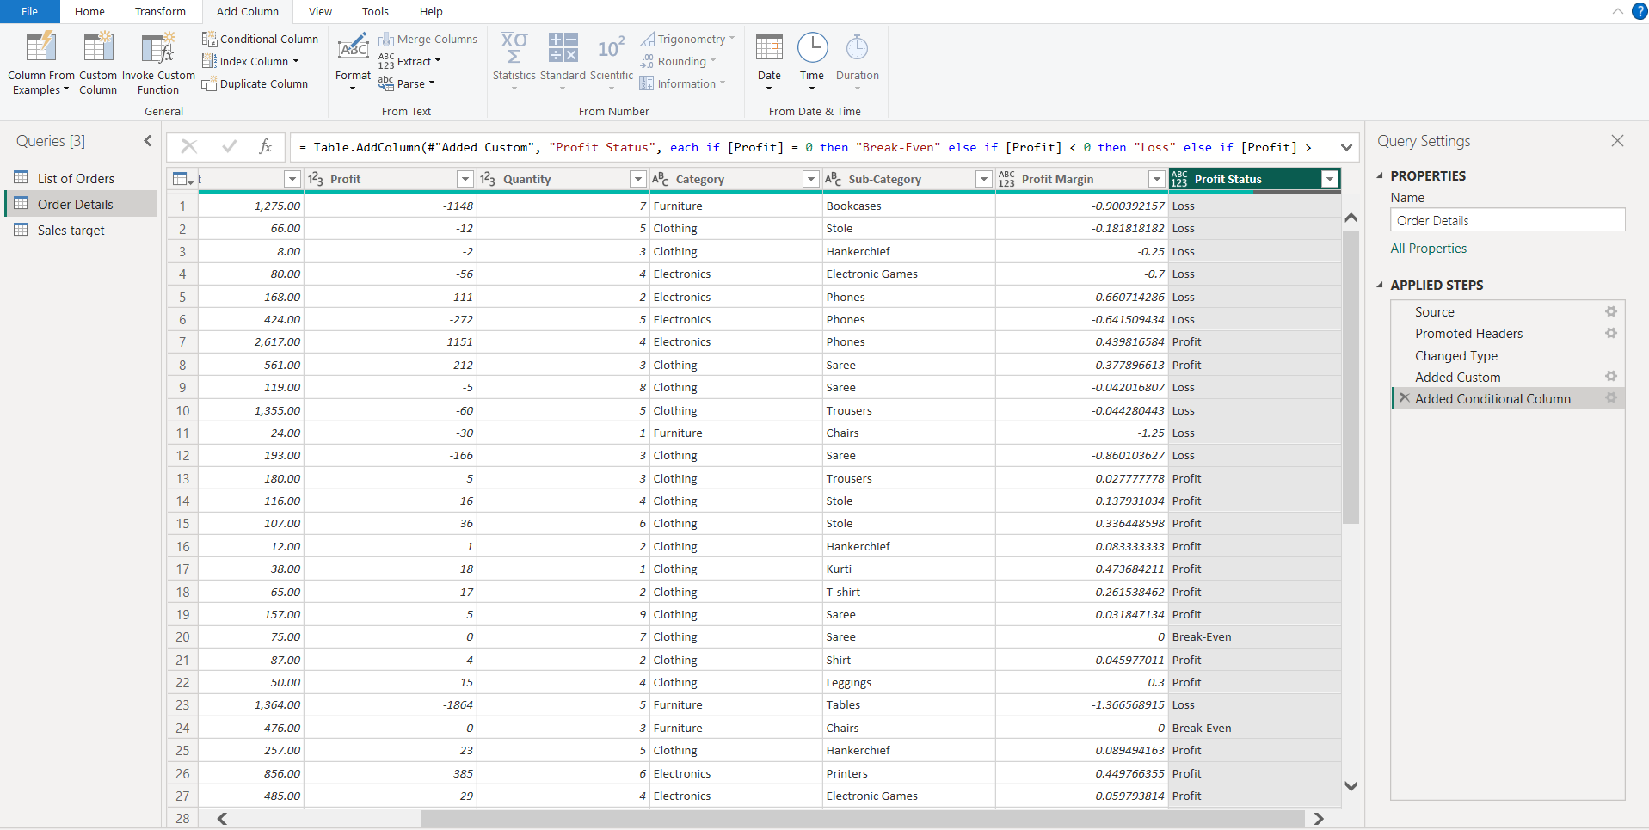

Merging Data (Joins):
● Merge the "List of Orders" and "Order Details" tables into a new single table named "Orders Data" based on the "Order ID" relationship.
Using merge queries option merge the "List of Orders" and "Order Details" tables into a new single table named "Orders Data"
Merge queriesSelect the 2 tables to mergeselect the order id option in both tables.

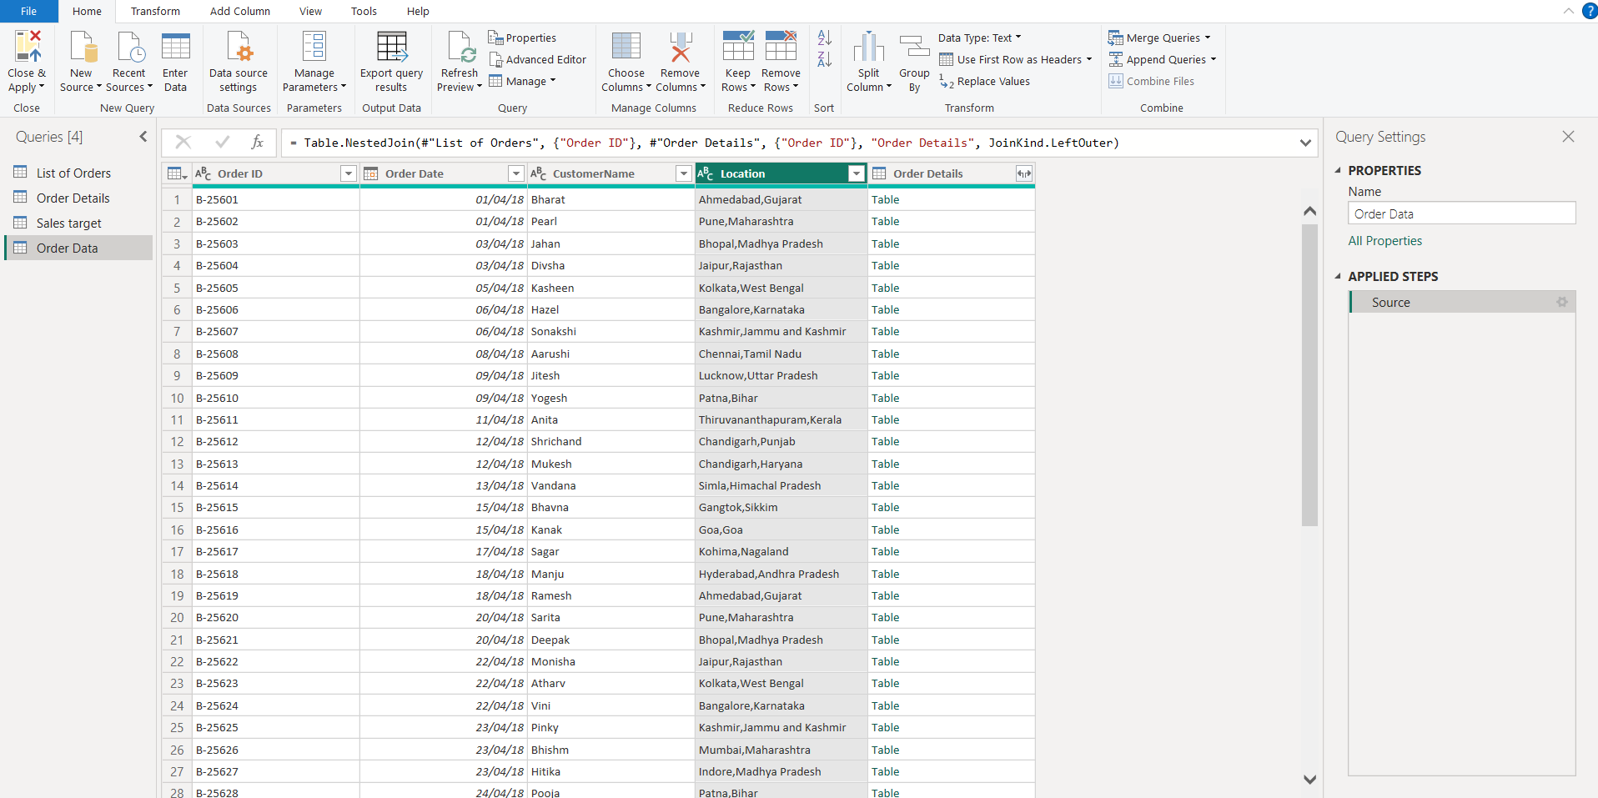

Handling Missing Data & Duplicate Data:
● Identify missing values in the data and determine a strategy to address them.
If it’s a numerical column then average value of that column is given or we handle missing value using coalesce.
● Check for duplicate rows and define a strategy to handle duplicates.
Remove RowsRemove Duplicate Rows.

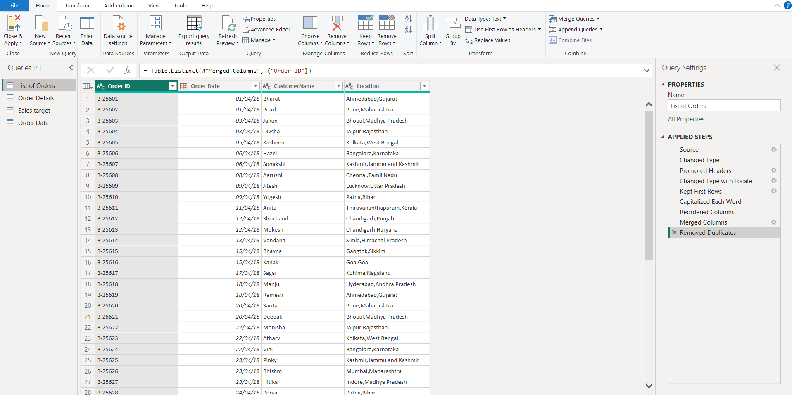

Sorting and Filtering Data:
● In the ‘Orders Data’ table, utilize sorting and filtering techniques on columns like Order Date, State or Category to analyze data based on specific criteria:
◆ Sort the orders by Order Date in descending order to analyze recent trends.
Select “Order DATA” select descending order
◆ Filter the orders to focus only on a specific state (e.g., Tamil Nadu) for regional analysis.
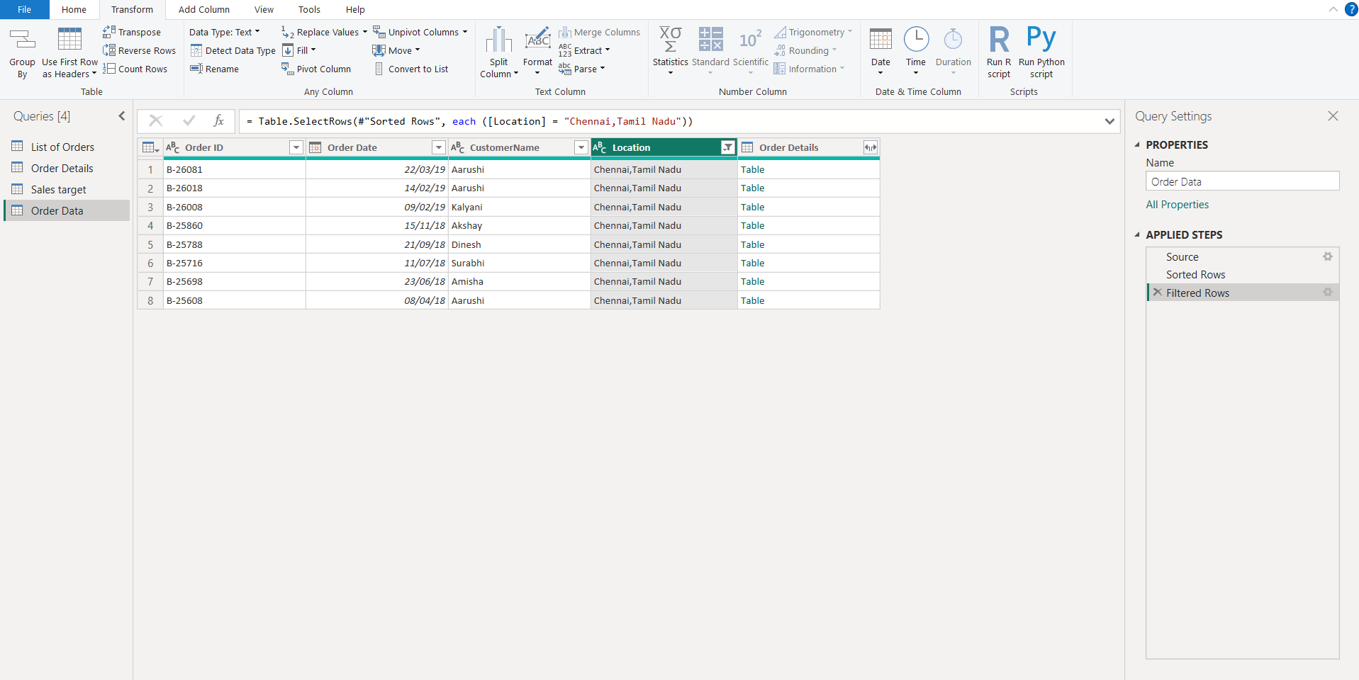

Grouping and Aggregating Data:
● Duplicate the “Order Details” table and calculate the count of each Order ID, average profit by Category or total amount by Sub-Category.
● Duplicate the “Sales Target” table and aggregate the total target amount by Month of Order Date.
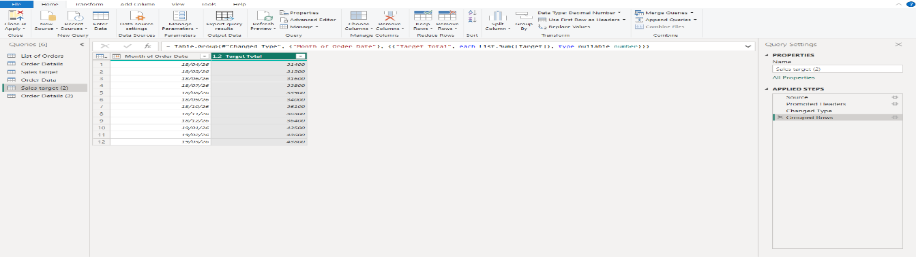
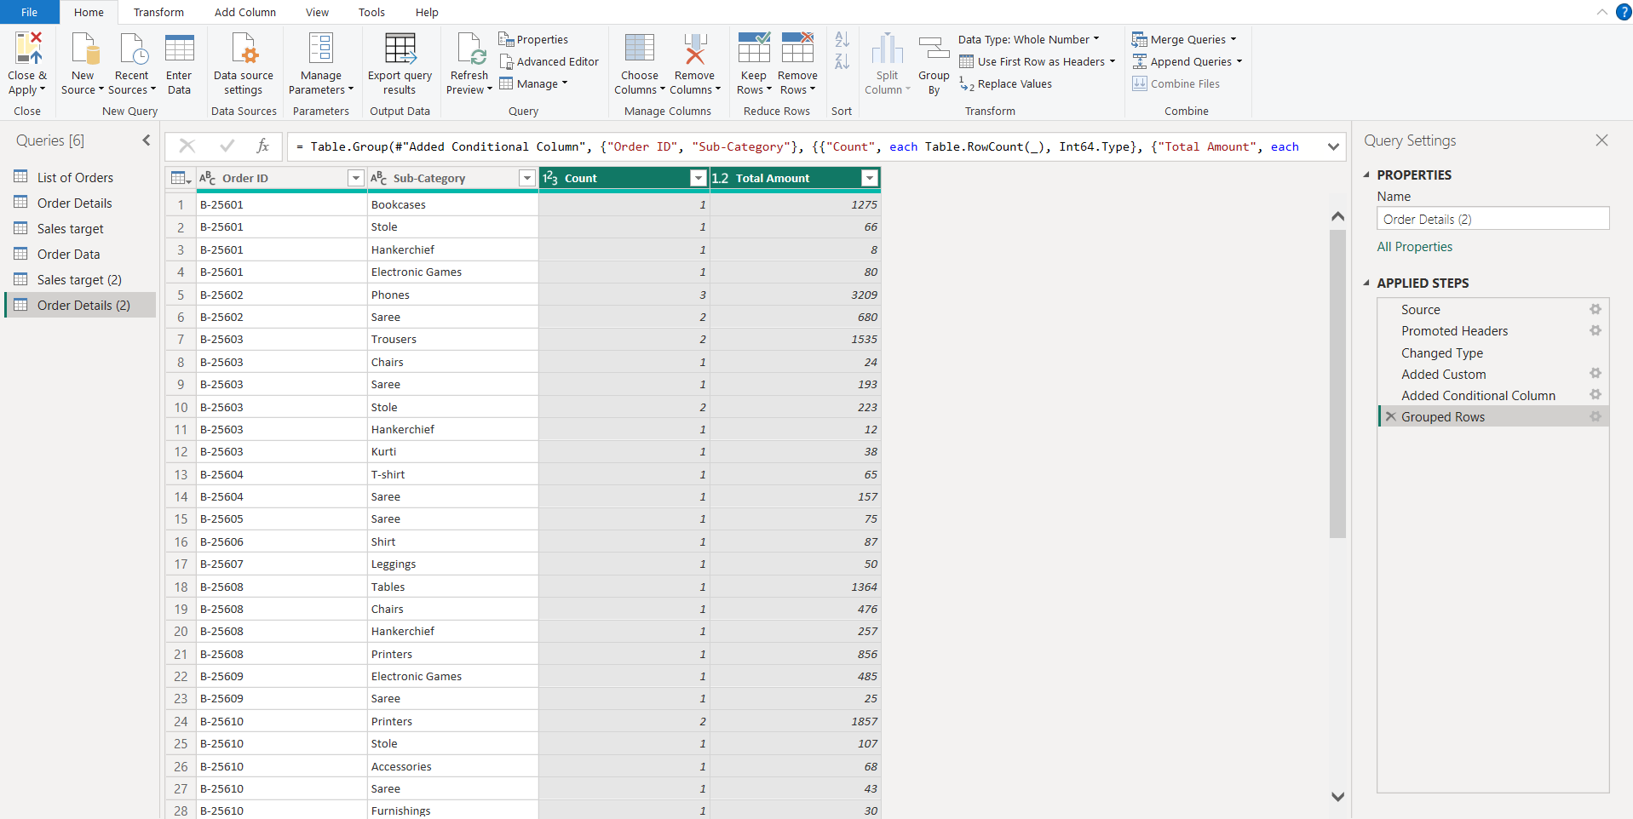
Data Modeling:
● Establish a relationship between the “List of Orders” and “Order Details” tables using the ‘Order ID’ column.
Reprot viewManage relationshipsNew relationshipselect the “List of Orders” and “Order Details” tables using the ‘Order ID’ column.
● Build a relationship between the “Order Details” and “Sales Target” tables based on the ‘Category’ column. Click "Manage relationships" and ensure this relationship is active.
Reprot viewManage relationshipsNew relationship select the “Order Details” and “Sales Target” tables based on the ‘Category’ column.
